TOPIC 5.1 : MAXIMUM COINS COLLECTION
Problem Statement
There are 3n piles of coins of varying size. You and your friends will take piles of coins as follows:
- In each step, you will choose any 3 piles of coins (not necessarily consecutive).
- Alice will pick the pile with the maximum number of coins.
- You will pick the next pile with the maximum number of coins.
- Bob will pick the last pile.
Repeat until there are no more piles of coins.
Given an array of integers piles where piles[i] is the number of coins in the ith pile, return the maximum number of coins that you can have.

Example 1
Input: piles = [2,4,1,2,7,8]
Output: 9
Explanation:
- Choose triplet (2,7,8): Alice → 8, You → 7, Bob → 2
- Choose triplet (1,2,4): Alice → 4, You → 2, Bob → 1
Your total = 7 + 2 = 9

Example 2
Input: piles = [2,4,5]
Output: 4

Aim
To write a program that finds the maximum number of coins you can collect by selecting optimal triplets from the given piles of coins.

Algorithm
- Start
- Read the array of integers piles
- Sort the array in descending order
- Initialize result = 0
- Iterate through the array by choosing every second element starting from index 1 (second largest in each triplet)
  - Add this element to result
- Continue until all triplets are used
- Return result
- Stop

Input and Output
- Input: piles = [2,4,1,2,7,8] → Output: 9
- Input: piles = [2,4,5] → Output: 4
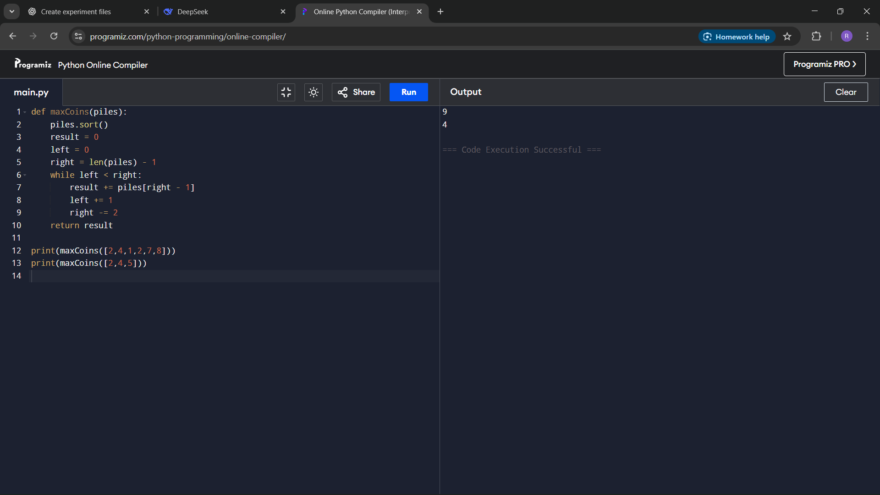

Result
The program successfully finds the maximum number of coins you can collect by following the rules of the game.

Performance Analysis
- Time Complexity:
  - Sorting → O(n log n)
  - Selecting coins → O(n)
  - Overall → O(n log n)
- Space Complexity:
  - O(1) if sorting is done in-place, otherwise O(n)

